Zheng Yin

V00915261

CSC349a

Assignment 1

Question 1：

(a)

function Euler(m,c,g,t0,v0,tn,n)

fprintf('values of t approximations v(t)\n')

fprintf('%8.3f',t0),fprintf('%19.4f\n',v0)

h=(tn-t0)/n;

t=t0;

v=v0;

for i=1:n

v=v+(g-c/m\*v)\*h;

t=t+h;

fprintf('%8.3f',t),fprintf('%19.4f\n',v)

end

(b)

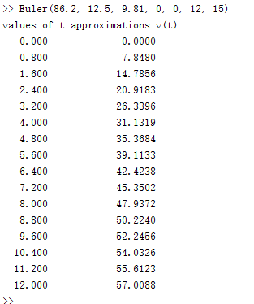

(c)

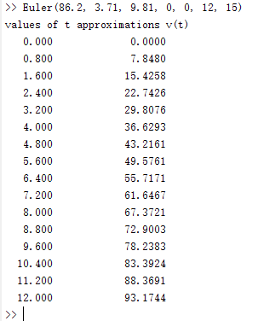

(d)

function relativeError(m,c,g,t0, v0, tn, n)

fprintf('values of t RelativeError(V1 as VE) RelativeError(V2 as VE)\n')

fprintf('%8.3f',t0),fprintf('%19.4f',v0),fprintf('%30.5f\n',v0)

h = (tn-t0)/n;

t = t0;

v1 = v0;

v2 =v0;

for i=1:n

v1= g\*m/c\*(1-exp(-(c\*(t+h)/m)));

v2 =v2+(g-c/m\*v2)\*h;

RE1 = abs((v1-v2)/v2);

RE2 = abs((v2-v1)/v1);

t = t+h;

fprintf('%8.3f',t),fprintf('%19.4f%%',RE1\*100),fprintf('%30.5f%%\n',RE2)

end

>> relativeError(86.2,12.5,9.81,0,0,12,15)

values of t RelativeError(V1 as VE) RelativeError(V2 as VE)

0.000 0.0000 0.00000

0.800 5.5825% 0.05913%

1.600 5.2580% 0.05550%

2.400 4.9460% 0.05203%

3.200 4.6468% 0.04873%

4.000 4.3602% 0.04559%

4.800 4.0862% 0.04260%

5.600 3.8248% 0.03977%

6.400 3.5757% 0.03708%

7.200 3.3388% 0.03454%

8.000 3.1139% 0.03214%

8.800 2.9008% 0.02987%

9.600 2.6991% 0.02774%

10.400 2.5086% 0.02573%

11.200 2.3289% 0.02384%

12.000 2.1598% 0.02207%

Question 2

(a)

function Euler(m,k,g,t0,v0,tn,n)

% print headings and initial conditions

fprintf('values of t approximations v(t) dv/dt\n ')

fprintf('%8.3f',t0),fprintf('%19.4f',v0), fprintf('%30.5f\n',v0)

% compute step size h

h=(tn-t0)/n;

% set t,v to the initial values

t=t0;

v=v0;

% compute v(t) over n time steps using Euler¡¯s method

for i=1:n

dv = g-k/m\*v^2;

v=v+dv\*h;

t=t+h;

fprintf('%8.3f',t),fprintf('%19.4f',v),fprintf('%30.5f\n',dv )

end

(b)

>> Euler2(73.5,0.234,9.81, 0,0,18,72)

values of t approximations v(t) dv/dt

0.000 0.0000 0.00000

0.250 2.4525 9.81000

0.500 4.9002 9.79085

0.750 7.3336 9.73355

1.000 9.7433 9.63878

1.250 12.1202 9.50777

1.500 14.4558 9.34232

1.750 16.7420 9.14471

2.000 18.9714 8.91763

2.250 21.1374 8.66415

2.500 23.2343 8.38756

2.750 25.2572 8.09134

3.000 27.2019 7.77906

3.250 29.0655 7.45426

3.500 30.8456 7.12042

3.750 32.5408 6.78089

4.000 34.1505 6.43879

4.250 35.6748 6.09702

4.500 37.1143 5.75817

4.750 38.4705 5.42458

5.000 39.7450 5.09824

5.250 40.9402 4.78086

5.500 42.0587 4.47384

5.750 43.1033 4.17829

6.000 44.0770 3.89508

6.250 44.9832 3.62481

6.500 45.8252 3.36786

6.750 46.6063 3.12445

7.000 47.3300 2.89459

7.250 47.9995 2.67817

7.500 48.6182 2.47497

7.750 49.1894 2.28464

8.000 49.7161 2.10679

8.250 50.2013 1.94094

8.500 50.6480 1.78659

8.750 51.0588 1.64318

9.000 51.4363 1.51017

9.250 51.7831 1.38697

9.500 52.1013 1.27302

9.750 52.3933 1.16777

10.000 52.6609 1.07064

10.250 52.9062 0.98112

10.500 53.1309 0.89869

10.750 53.3366 0.82284

11.000 53.5249 0.75311

11.250 53.6971 0.68906

11.500 53.8547 0.63025

11.750 53.9988 0.57630

12.000 54.1305 0.52683

12.250 54.2509 0.48149

12.500 54.3608 0.43996

12.750 54.4613 0.40192

13.000 54.5531 0.36711

13.250 54.6369 0.33526

13.500 54.7134 0.30612

13.750 54.7833 0.27948

14.000 54.8471 0.25512

14.250 54.9053 0.23286

14.500 54.9584 0.21252

14.750 55.0069 0.19394

15.000 55.0512 0.17696

15.250 55.0915 0.16146

15.500 55.1284 0.14731

15.750 55.1620 0.13438

16.000 55.1926 0.12259

16.250 55.2206 0.11182

16.500 55.2461 0.10199

16.750 55.2693 0.09303

17.000 55.2905 0.08484

17.250 55.3099 0.07738

17.500 55.3275 0.07057

17.750 55.3436 0.06435

18.000 55.3583 0.05868

(c) When t =18, the relative error is about 0.0717% by dv/dt=g-k\m\*v^2 function.

The relative error is about 0.00072% by exact (c) function.

Question 3

function MLseries(x,t)

fprintf('terms first function second function RE by 1st fun RE by 2nd fun\n')

FFun = 0;

SFun0 = 0;

trueValue = 0.135335;

for i=0:t

FFun = FFun+ (-x)^i/factorial(i);

SFun0 = SFun0 + x^i/factorial(i);

SFun = 1/SFun0;

RE1 = abs((trueValue-FFun)/FFun)\*100;

RE2 = abs((trueValue-SFun)/SFun)\*100;

fprintf('%8.3f',i),fprintf('%19.4f',FFun),fprintf('%25.5f',SFun),fprintf('%20.5f%%',RE1),fprintf('%20.5f%%\n',RE2)

end

